**Raspberry Pi As Access Point**

Some of features that should be done before installing features for access point in Raspberry Pi.

* Update your Raspberry Pi
* Then upgrade it
* sudo apt-get update
* sudo apt-get dist-upgrade
* sudo reboot

Then you have to install the access point features by entering command into your Raspberry Pi

* curl -sL https://install.raspap.com | bash

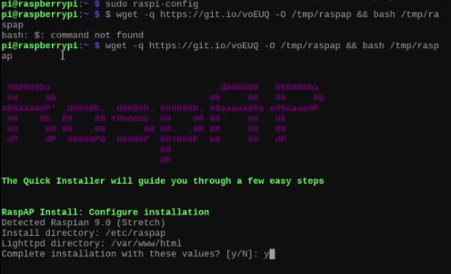

In figure, the RaspAP is been shown which shows the installation process is been start, after pressing (y/Y) the installation begins and till end press (y/Y) to install each features and then reboot the Raspberry Pi.

**Configuration:**

After installation of the files from the RaspAp.com, follow the steps.

* Open any browser i-e Chrome, Firefox etc.
* Reach to the default access point 10.3.141.1
* Login to the server,
* Username= admin
* Password= ChangeMe

First of all connect all the required wires such as Ethernet cable to the wifi router and then configure all the settings.

**Done!**